A picture containing clipart

Description generated with very high confidence

Azure 103 Hands On - 2

Azure Certification Training

[**support@intellipaat.com**](mailto:support@intellipaat.com)

**+91-7022374614**

**US: 1-800-216-8930(Toll Free)**

**Azure 103 Hands On - 2**

**Problem Statement: Move resource from one resource group to another.**

**Step 1:** Go to portal.azure.com and sign into your Azure account. Azure dashboard page of your Azure portal will appear on the screen as shown below.

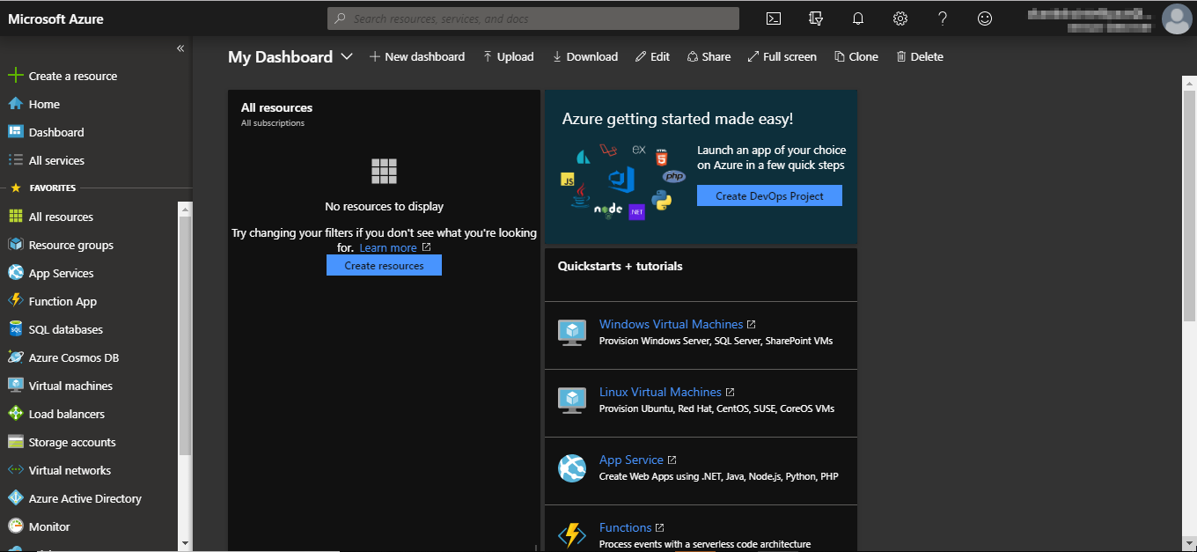

**Step 2:** Navigate to the **Resource groups** option on the left side menu as shown in the following image.

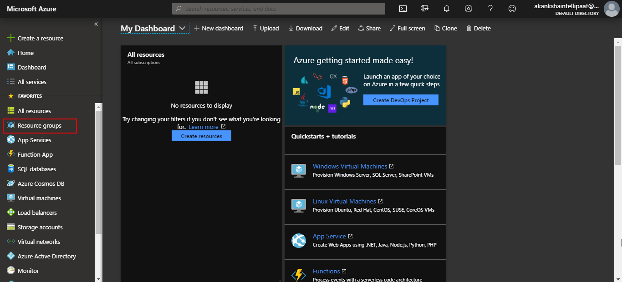

**Step 3:** Click on **Resource groups** option and you will be taken to the resource groups dashboard where you’ll see various options such as **add, edit column and more.** Click on add option.

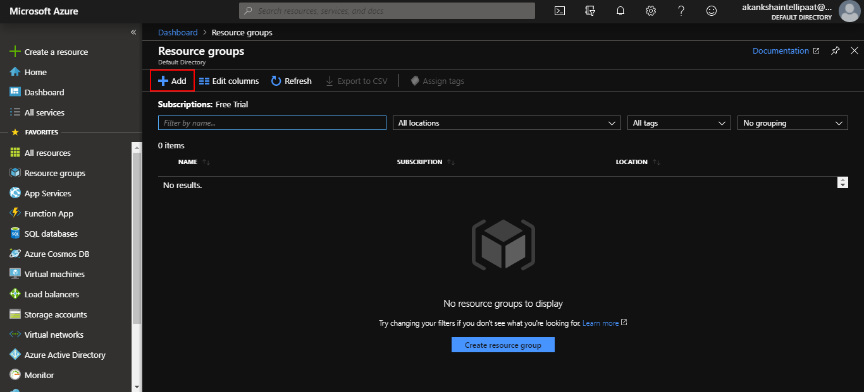

**Step 4:** Provide a name for your resource group in the respective field. You can keep the subscription as per your Azure subscription. And then click on Review & create.

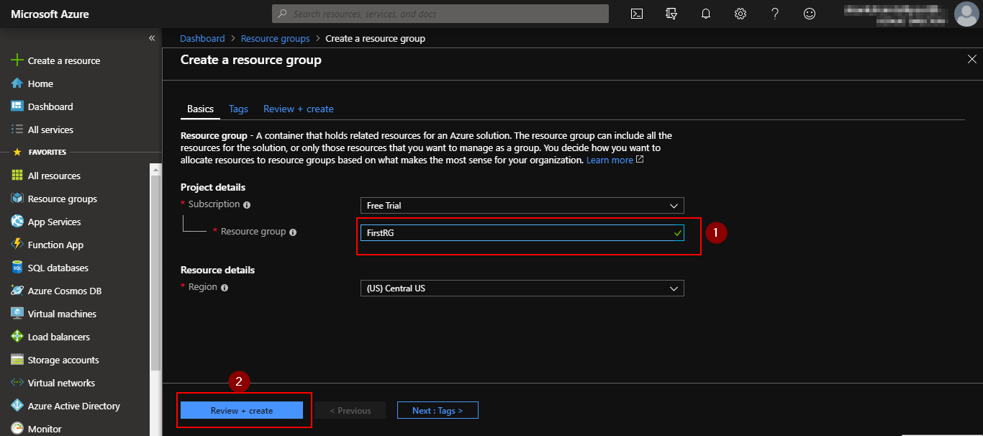

**Step 5:** Follow the same process and create one more resource group named **SecondRG.**

**Step 6:** Follow the same steps from 6 to 10 from hands on 1 and deploy resources in resource group named FirstRG.

**Step 7:** Go to **resource groups** section and enter the resource group from where you want to move the resources. In this case, we will move resources from the FirstRG resource group.

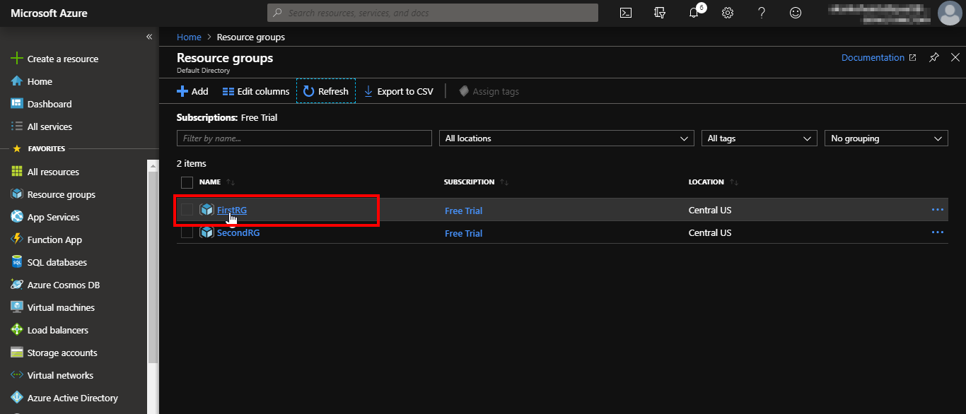

**Step 8:** Once inside FirstRG resource group, click on the move button and then select “Move to another resource group”.

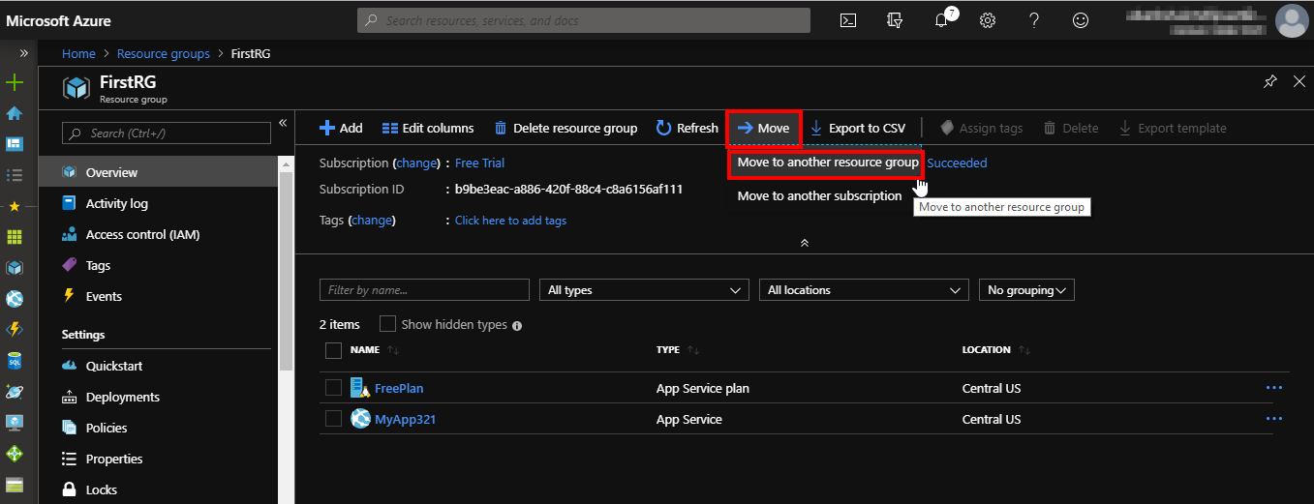

**Step 9:**

1. Select the resources that you want to move by checking the box next to the name of the resource.
2. In “Move these resources to” section provide the name of the resource group where you want to move these resources. In this case, it’s **SecondRG**.
3. Then check the box for the agreement line.

And then click OK.

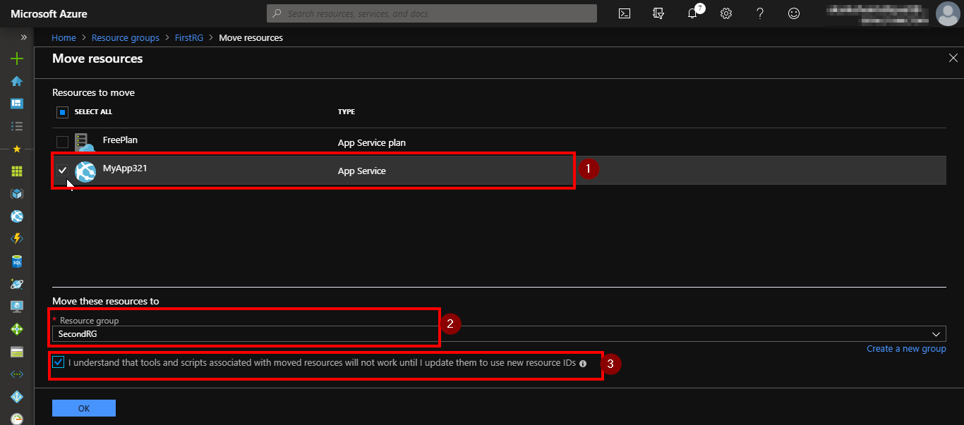

**Step 10:** Go to the SecondRG resource group and if the moving operation is still in process you will see a message as shown in the following screenshot.

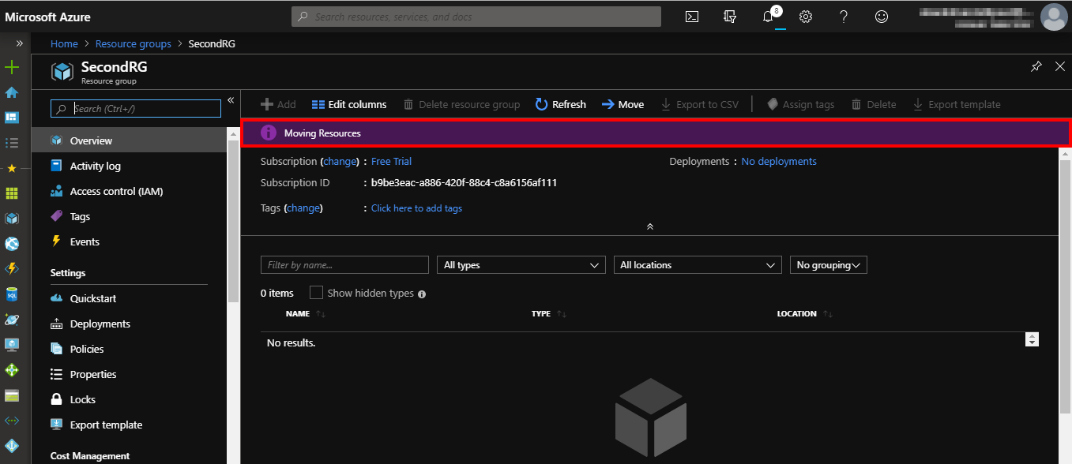

**Step 11:** After some time, you will be able to see the resource has been moved to this resource group as shown in the following screenshot.

